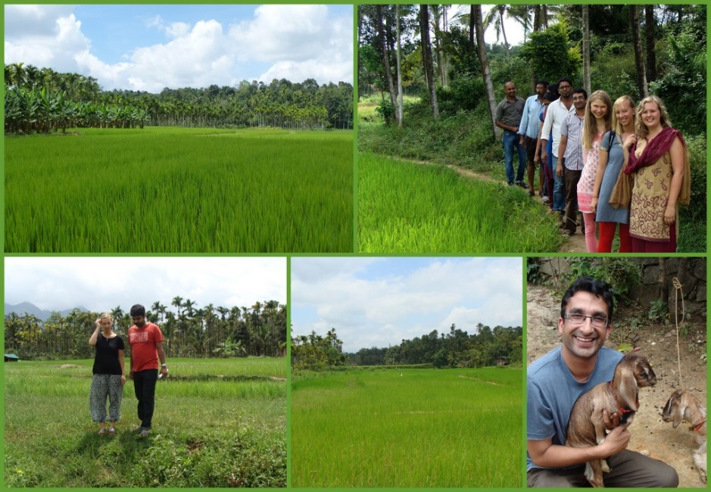

BioDIVA: “Marketing speciality Rice for Conservation” presentations at the research colloquium at Passau University

Three students from the University of Passau conducted field research for their Bachelor theses joining the BioDIVA project (http://www.biodiva.uni-hannover.de/en) in India. Lena Andorfer, Julia Kunze and Henrike Hoffmann investigated the current organizational structures of rice production as well as possibilities of marketing “Gandhakasala”, a traditionally grown rice species, in the domestic and export market. In the district of Wayanad, Kerala, India, more and more banana plantations replace rice fields, leading to a decrease of local agrobiodiversity especially of rice varieties.
…
Ms. Hoffmann, Ms. Kunze and Ms. Andorfer did not only carry out their research, but furthermore, they organized and conducted a stakeholder workshop. The workshop brought together farmers, mill owners, NGOs as well as traders. They discussed the potentials of marketing “Gandhakasala” rice, which could give local farmers a secure and sufficient income. An additional outcome of the students field work was the interest expressed by a German trader in the precious and nice scented rice.
After the presentations BioDIVA Team leader Prof. Martina Padmanabhan celebrated the success of the project with the student research team and the colloquium participants.

